EXPERIMENT - 2
NAME: Padma Priya D ROLL NO:240701377
Design a UI where users recall visual elements (e.g., icons or text chunks). Evaluate the effect of chunking on user memory.

FRAME 1: INSTRUCTION PAGE

Chunking Analysis of the Instruction Page
Chunking is a cognitive technique that divides information into small and meaningful parts to improve understanding and memory retention. The Instruction Page of the designed game effectively applies this concept as explained below:

1. Clear and Sequential Instructions
• Instructions are displayed in step-by-step format.
• Each step explains one action clearly.
• This reduces confusion and improves user understanding.

2. Logical Grouping of Information
• Observation Stage → Users are instructed to view icons carefully.
• Memorization Stage → Users are guided to remember displayed elements.
• Recall Stage → Users are informed about the selection process.
• Performance Stage → Users are told that score depends on accuracy.

3. Visual Hierarchy and Layout Design
• The game title is placed at the top to grab attention.
• Instructions are properly spaced for better readability.
• The START GAME button is highlighted using color and size.

4. Simplicity and Clarity
• Simple language is used for easy understanding.
• Clean layout avoids unnecessary distractions.
• Users can quickly understand how the game works.

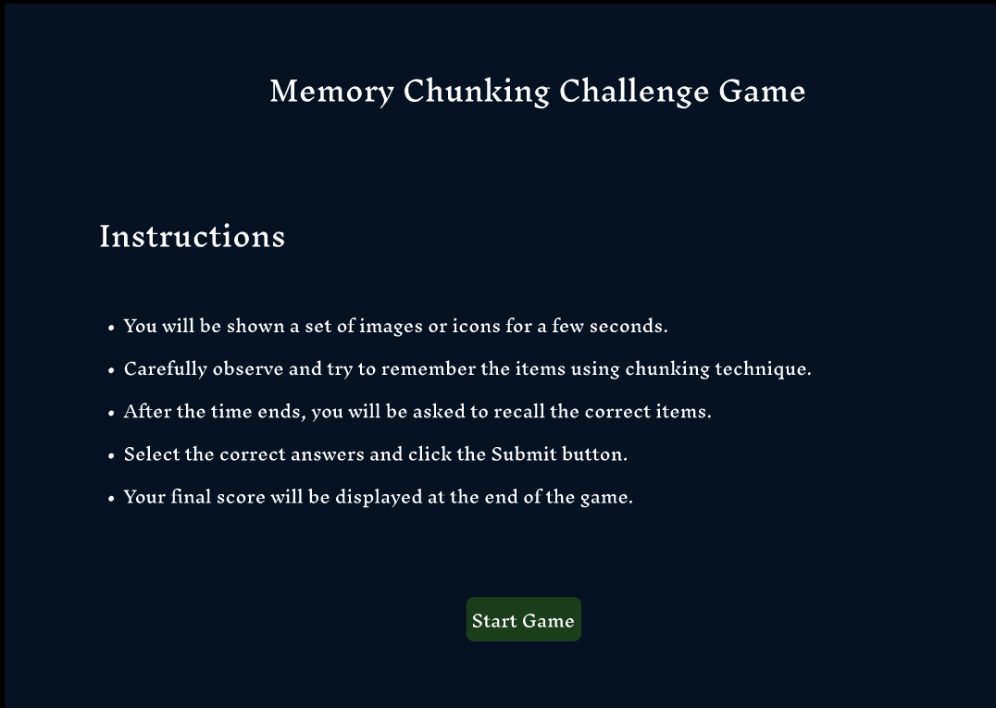

FRAME 2: CHUNKING PHASE

Analysis of the Chunking Phase Screen
This screen represents the memory observation phase where users view and memorize visual elements.

1. Purpose of the Screen
• Allows users to visually observe and encode information.
• Helps users apply chunking strategy by grouping similar icons.
• Prepares the user for the recall phase.

2. Key UI Components

⏱ Timer Display
• Displays limited viewing time.
• Creates urgency and improves concentration.

🧩 Icon Grid Layout
• Icons are arranged in rows and columns.
• Structured grid helps users group items easily.
• Users can chunk items based on color, shape, or category.

📊 Progress Indicator
• Shows remaining time visually.
• Helps users manage memorization strategy effectively.

3. Chunking Benefits
• Improves short-term memory retention.
• Reduces mental overload.
• Helps users remember grouped data instead of individual items.

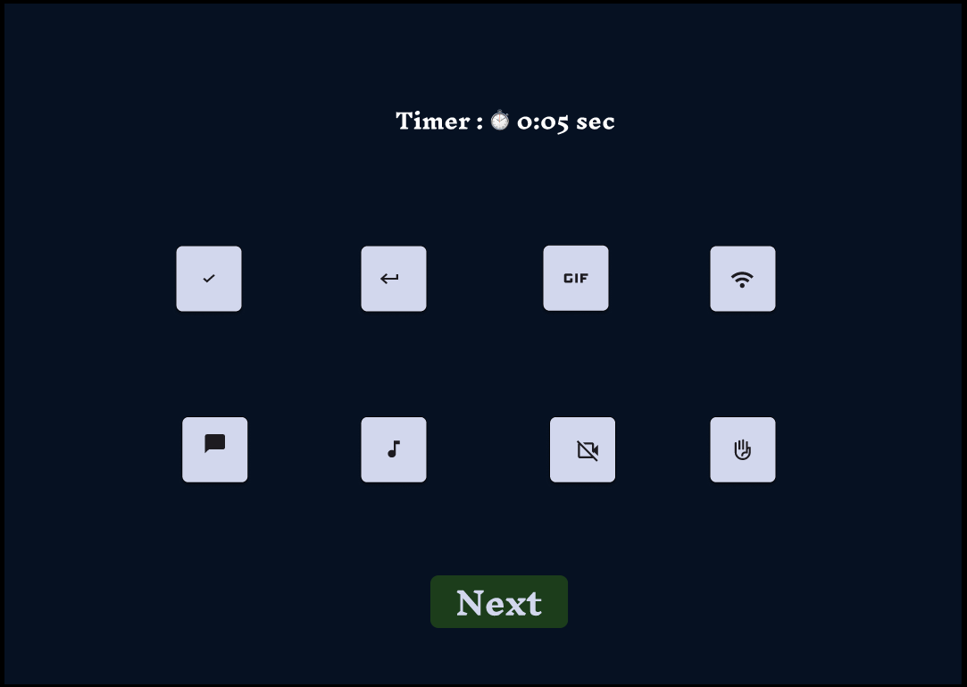

FRAME 3: RECALL PHASE

Analysis of the Recall Phase Screen
This screen allows users to retrieve and select items remembered from the Chunking Phase.

1. Purpose of the Screen
• Tests the effectiveness of memory recall.
• Measures how well chunking helped retain information.

2. UI Components

📝 Instruction Text
• Guides users to select remembered items.
• Clear instructions minimize user errors.

🔲 Option Grid
• Displays correct icons along with distractor icons.
• Encourages careful selection and memory recall.

✅ Selection Buttons
• Allows users to choose answers easily.
• Improves interaction clarity and usability.

📤 Submit Button
• Confirms the selected answers.
• Navigates the user to the result screen.

3. Cognitive Benefits
• Evaluates memory accuracy.
• Tests effectiveness of chunking strategy.
• Improves concentration and recall performance.
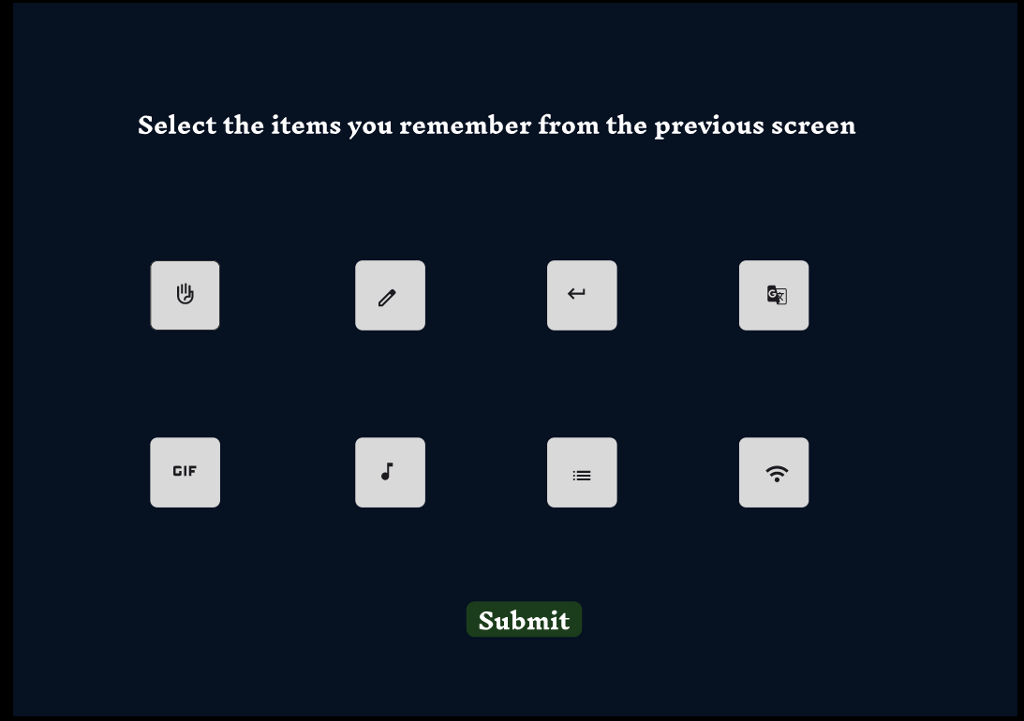

FRAME 4: RESULT PAGE

Analysis of the Result and Feedback Screen
This screen displays the final performance of the user after completing the recall phase.

1. Purpose of the Screen
• Displays user score and feedback.
• Helps users analyze their memory performance.

2. Key UI Elements

📈 Score Display
• Shows total correct answers clearly.
• Large font size improves visibility and readability.

🔘 Action Buttons
• Main Menu – Allows the user go to game menu.
• Restart – Enables replay to improve performance.
• Close – Ends the game session.

3. User Experience Benefits
• Instant feedback motivates learning improvement.
• Multiple options give user control.
• Enhances engagement and interaction quality.
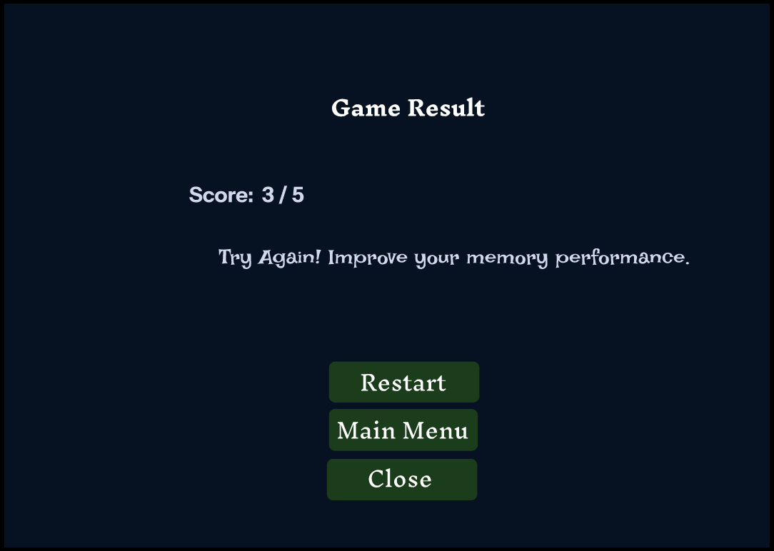
PROTOTYPE LINK
https://www.figma.com/proto/WuwTco8M3WskhCzyO0cs63/Memory-Game?node-id=1-7&starting-point-node-id=1%3A7&t=vkBHrCMnRqrzkbCR-1

